

Electromagnetic Flow-meter
KLLD Electromagnetic Flow-meter

Anhui Madsur Technology Co., Ltd
Valeria@madsurgroup.com
+8618256639967
www.madsurgroup.com
Anhui-China

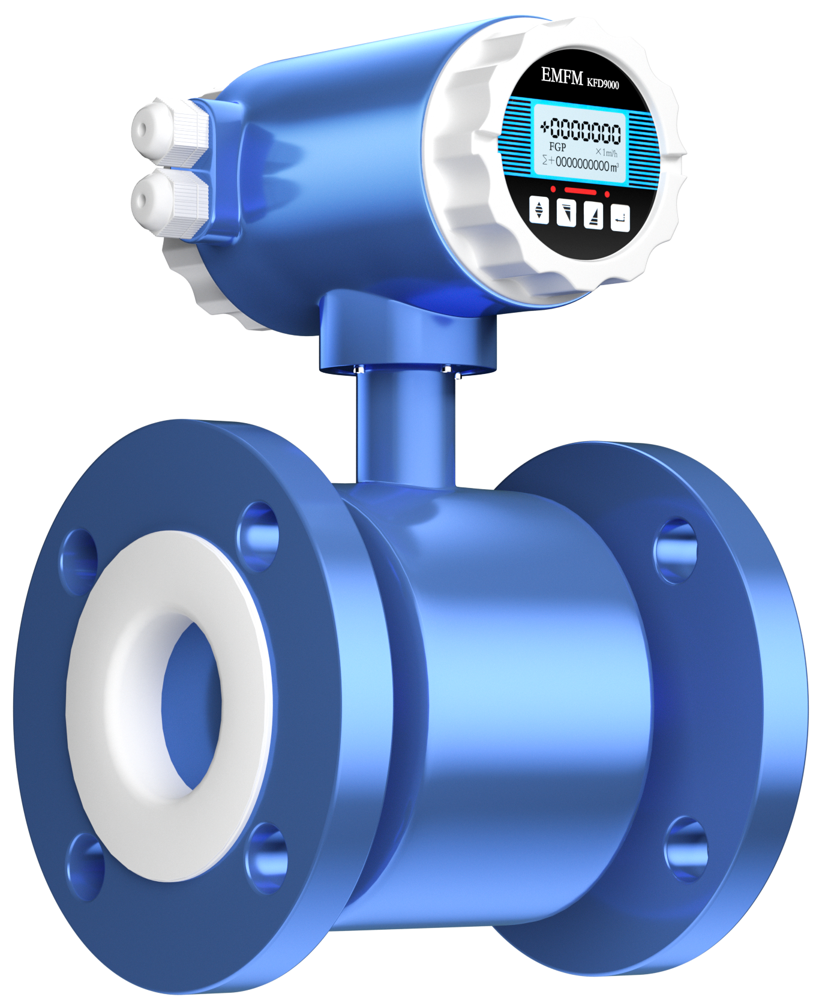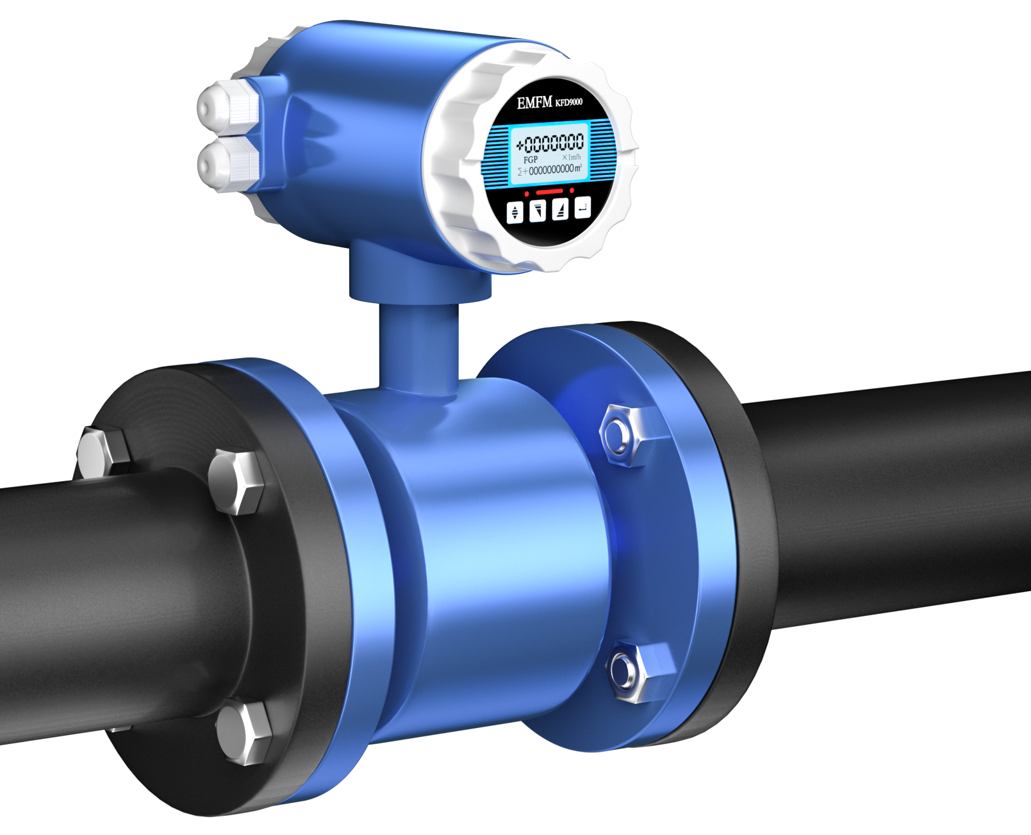

Working principle
The KLLD electromagnetic flow-meter is manufactured using the latest electromagnetic flow-meter technology and features the following characteristics:
a) Measurement is unaffected by changes in fluid density, viscosity, temperature, pressure, and conductivity;
b) There are no obstructive flow components inside the measuring pipe, resulting in no pressure loss and lower straight pipe section requirements;
c) The series is available in nominal diameters from DN6 to DN3000. A variety of sensor lining and electrode materials are available;
d) The converter employs a novel excitation method, resulting in low power consumption, zero-point stability, and high accuracy. Flow range ability up to 1500:1;
e) The converter can be integrated with the sensor or used separately;
f) The converter uses a 16-bit high-performance microprocessor, a 2x16 LCD display, convenient parameter setting, and reliable programming;
g) The flow meter is a bidirectional measurement system with three built-in total izers: forward total, reverse total, and differential total; it can display forward and reverse flow rates and has multiple outputs: current, pulse, digital communication, and HART;
h) The converter uses surface mount technology (SMT) and has self-testing and self-diagnostic functions;
i) The rubber and polyurethane lined sensor has an intrinsically immersive structure;
j) Explosion-proof instruments can be used in appropriate explosion-proof environments;
k) The KLLD electromagnetic flow meter is used to measure the volumetric flow rate of conductive liquids and slurry in closed pipes and is suitable for chemical, power, metallurgical, petroleum, water supply and drainage, paper-making, pharmaceutical, and food industries.

Machine and Sensors
Maximum flow rate | 15m/s
Accuracy  (See accuracy curve) | DN15~DN600 |  | ±0.3% (flow velocity ≥ 1 m/s), ±0.2%** of the indicated value
Accuracy  (See accuracy curve) |  |  | ±3mm/s (flow velocity <1m/s)
Accuracy  (See accuracy curve) | DN700~DN3000* |  | ±0.5% of the indicated value (flow velocity ≥ 0.8 m/s)
Accuracy  (See accuracy curve) |  |  | ±4mm/s(Flow rate<0.8m/s)
Fluid conductivity | ≥5μs/cm
Nominal pressure | DN15~DN150 |  | 4.0MPa
Nominal pressure | DN15~DN600 |  | 1.6MPa
Nominal pressure | DN200~DN1000 |  | 1.0MPa
Nominal pressure | DN700~DN3000 |  | 0.6MPa
Ambient temperature | sensor |  | -25°C~+60°C
Ambient temperature | Converter and all-in-one |  | -10°C~+60°C
Lining material and maximum fluid temperature | Lining material | Separate type |  | all-in-one
Lining material and maximum fluid temperature | Polytetrafluoroethylene (PTFE) | 100°C;150°C (Customization required) |  | 70°C
Lining material and maximum fluid temperature | Polyfluoroethylene (PFO) | 100°C;150°C(Customization required) |  | 70°C
Lining material and maximum fluid temperature | Perfluoroethylene (PFO) | 100°C;150°C(Customization required) |  | 70°C
Lining material and maximum fluid temperature | Polychloroprene rubber | 80°C;120°C(Customization required) |  | 70°C
Lining material and maximum fluid temperature | Polyurethane | 80°C |  | 70°C
Signal electrode type | Fixed type (DN15~DN2600), scraper type (DN300~DN1600)
Signal electrode and grounding electrode materials | Molybdenum-containing stainless steel, Hastelloy B, Hastelloy C, titanium, tantalum, platinum-iridium alloy, stainless steel coated with tungsten carbide
Connecting flange material | Carbon steel
Grounding flange material | Stainless steel 1Cr18Ni9Ti
Protective flange material | DN15~DN600 |  | Stainless steel 1Cr18Ni9Ti
Protective flange material | DN700~DN3000 |  | Carbon steel
Enclosure Protection | DN15-DN150 Separate rubber or polyurethane lined sensors |  | IP65、IP68(Customization required)
Enclosure Protection | DN200-DN2600 Separate rubber or polyurethane lined sensors |  | IP68 underwater 10m
Enclosure Protection | Other sensors and all converters |  | IP65
Spacing  (Separation Type) | The distance between the converter and the sensor is generally no more than 100m;  if it exceeds 100m, a special order is required.

Nominal  diameter  DN | pressure1.6MPa |  |  |  |  | pressure4.0MPa |  |  |  |  |  | Nominal  diameter  DN | L | H | Sensor reference weight/Kg
Nominal  diameter  DN | D | d₁ | d₀ | n | b | D | d₁ | d₀ | n | b
15 | 95 | 65 | 14 | 4 | 16 | 95 | 65 | 14 | 4 | 16 |  | 15 | 200 | 160 | 3.6
20 | 105 | 75 | 14 | 4 | 18 | 105 | 75 | 14 | 4 | 18 |  | 20 | 200 | 167 | 4.2
25 | 115 | 85 | 14 | 4 | 18 | 115 | 85 | 14 | 4 | 18 |  | 25 | 200 | 169 | 5.0
32 | 140 | 100 | 18 | 4 | 18 | 140 | 100 | 18 | 4 | 18 |  | 32 | 200 | 185 | 6.3
40 | 150 | 110 | 18 | 4 | 20 | 150 | 110 | 18 | 4 | 20 |  | 40 | 200 | 193 | 7.3
50 | 165 | 125 | 18 | 4 | 20 | 165 | 125 | 18 | 4 | 20 |  | 50 | 200 | 206 | 8.5
65 | 185 | 145 | 18 | 4 | 20 | 185 | 145 | 18 | 4 | 22 |  | 65 | 250 | 224 | 11.2
80 | 200 | 160 | 18 | 8 | 22 | 200 | 160 | 18 | 8 | 22 |  | 80 | 250 | 241 | 12.2
100 | 220 | 180 | 18 | 8 | 22 | 235 | 190 | 22 | 8 | 26 |  | 100 | 250 | 263 | 15.2
125 | 250 | 210 | 18 | 8 | 22 | 270 | 220 | 26 | 8 | 26 |  | 125 | 250 | 295 | 18.2
150 | 285 | 240 | 22 | 8 | 24 | 300 | 250 | 26 | 8 | 28 |  | 150 | 300 | 325 | 25.0

